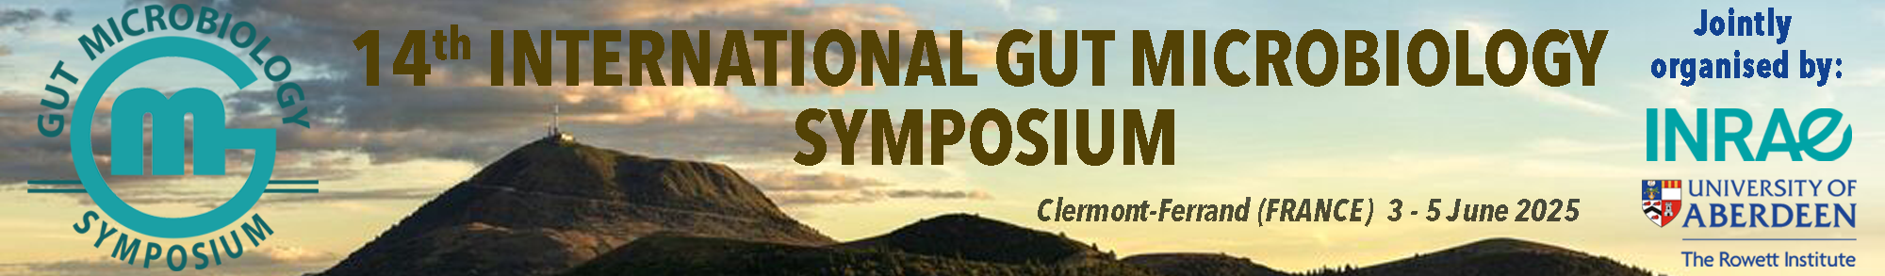

**Guidelines for abstract submission**

**14th International Gut Microbiology Symposium**

**Instructions for submission**

* Abstracts must be written in English, 300 words maximum (Arial narrow 11) Authors list and affiliations are not included in the 300 words No illustrations – No references
* Abstracts must be approved by all authors before submission. By submitting an abstract, the authors acknowledge that the abstract will be published in the abstract booklet.
* The presenting author’s name has to be underlined in the author’s list
* The submitting author will be the only point of contact with the organizers at each step (during submission, acceptance of the abstract...).
* The preferred format of presentation should be selected during submission from the 2 options:
  + Oral presentation
  + Poster presentation
* The Scientific Committee may offer the presenting author a presentation format different than the primary choice.
* For each submission, the presenting author should select the preferred session. The Scientific Committee may decide to assign the presentation to an alternative session.
* Upload the abstract as a Word or PDF document entitled “Session’s number_Name of the presenting author_Abstract number” (ex: 1_Name_01 for abstract #1 in session 1; 3_Name_02 for abstract #2 in session 3; etc…)

**Abstract template**

**14th International Gut Microbiology Symposium**

Title (less than 250 characters)

NAME First name1, NAME First name2 and NAME First name3

1Affiliation 1, City, COUNTRY

2Affiliation 2, City, COUNTRY

3Affiliation 3, City, COUNTRY

**Background**

**Methods**

**Results**

**Conclusions**

**Key words: maximum 5**

Selected sessions

⬜ Session 1 - Gut microbes in health, climate and environment: an intricate equation

⬜ Session 2 - Diet to optimize gut microbiota-host symbiosis

⬜ Session 3 - Local and distant roles of the gut microbiota

⬜ Session 4 - New approaches in gut microbiota research

⬜ Session 5 - Gut microbiology: from bench to bedside